**Phase 9: Reporting, Dashboards & Security Review**

**Reports (Tabular, Summary, Matrix, Joined)**

* Generate and analyze data in various formats.
* **Navigation**: App Launcher → Reports → New Report → Select Report Type → Choose Layout (Tabular, Summary, Matrix, Joined) → Run & Save.

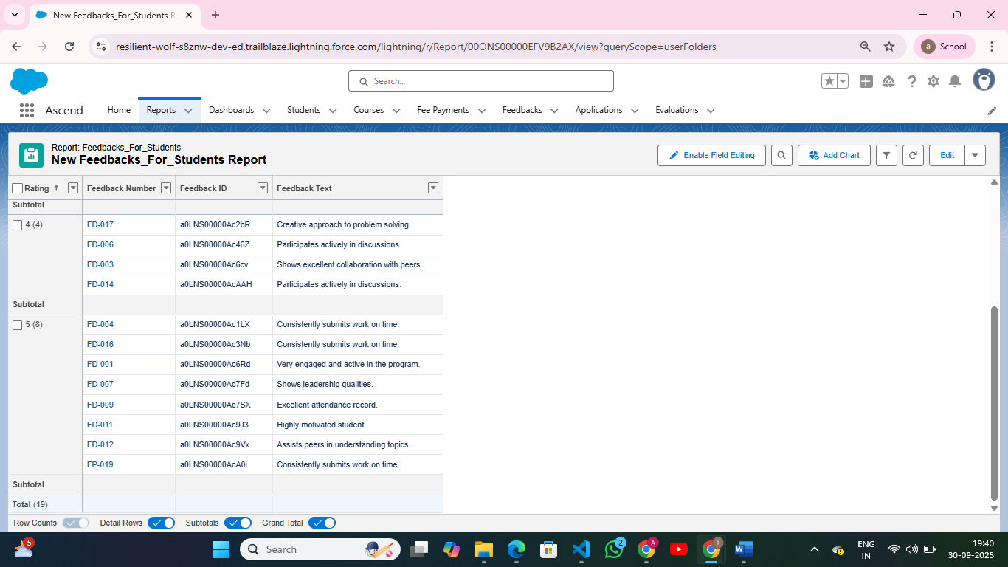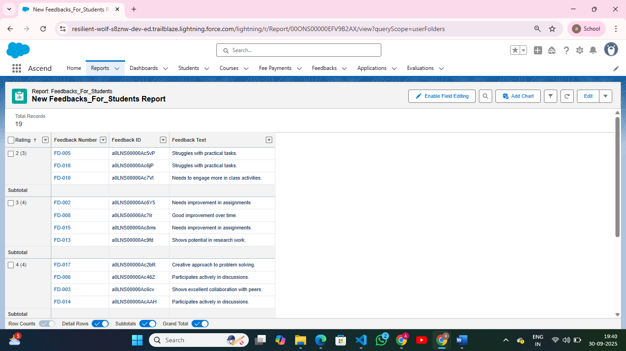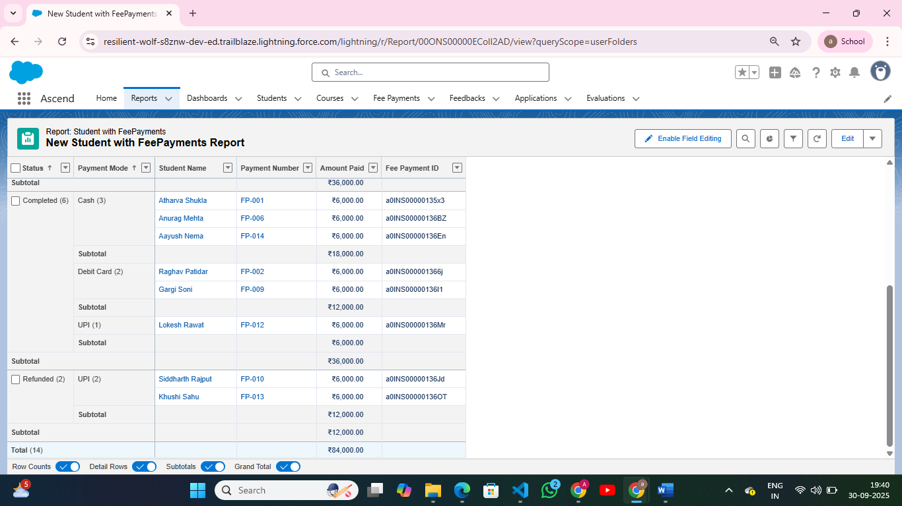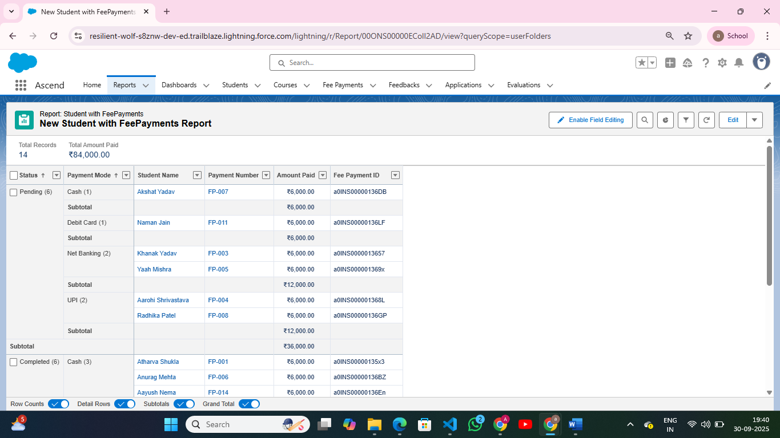

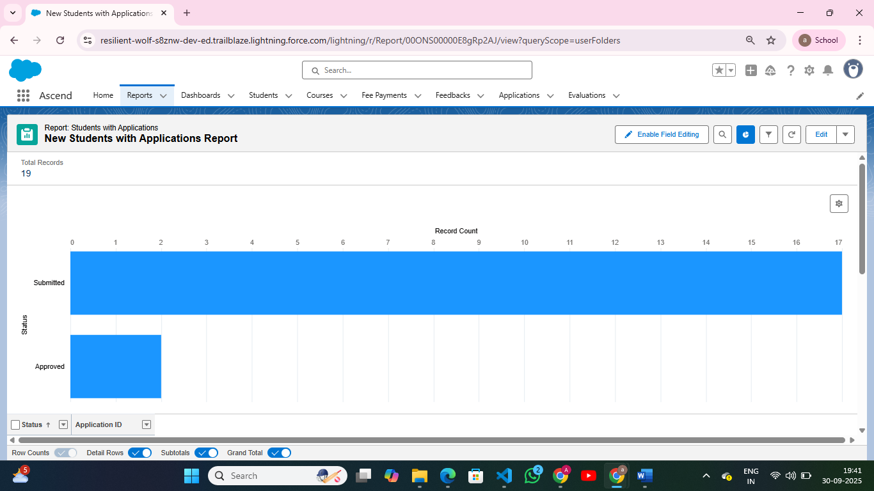

**Report Types**

* Define which objects and fields are available for reports.
* **Navigation**: Setup → Report Types → New Custom Report Type → Define Primary Object → Add Related Objects → Save.

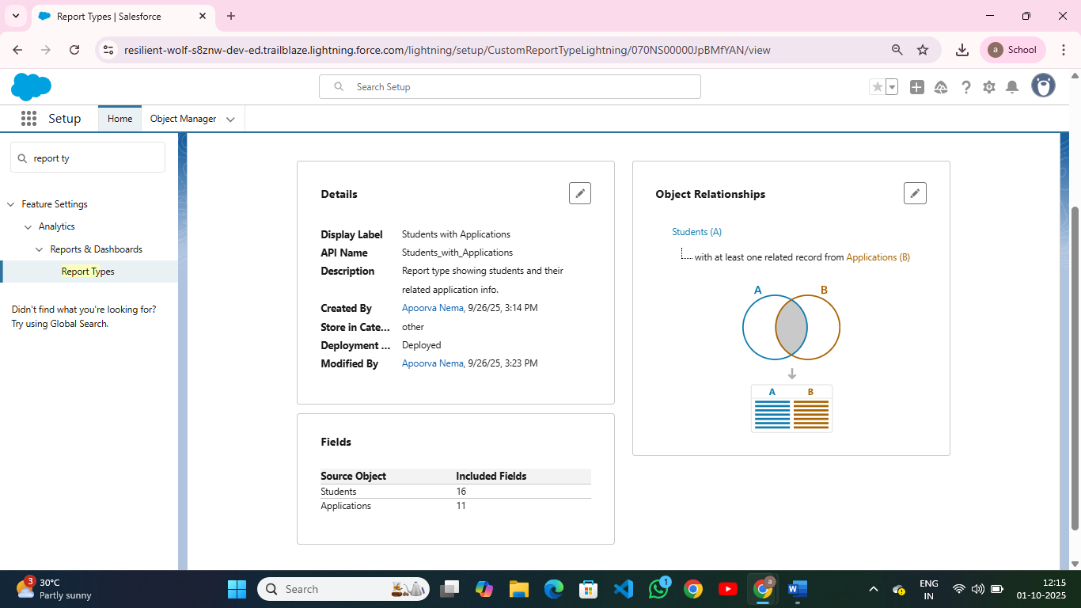

**Dashboards**

* Visualize reports using charts, tables, and metrics.
* **Navigation**: App Launcher → Dashboards → New Dashboard → Add Components → Choose Report → Configure Chart → Save & Run.

**Dynamic Dashboards**

* Display personalized data per user without creating multiple dashboards.
* **Navigation**: Dashboard Settings → “Run as Logged-in User” → Save.

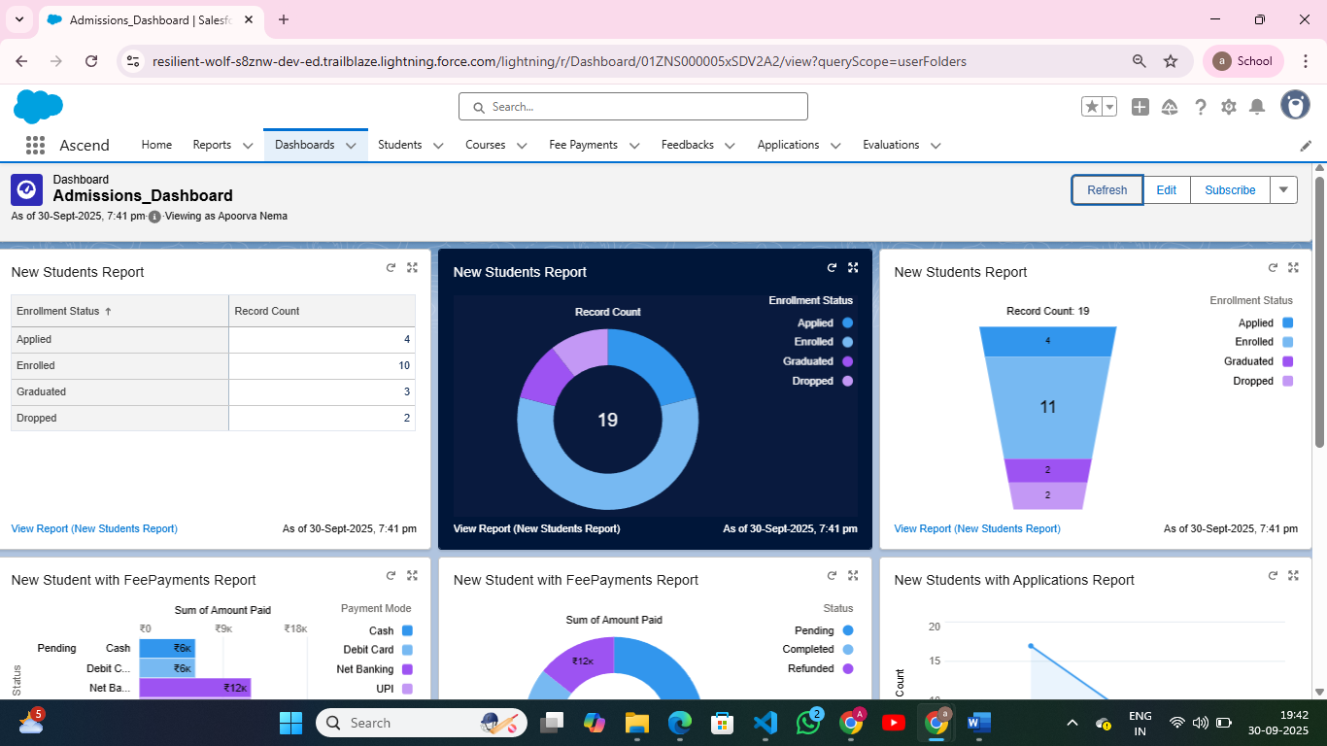

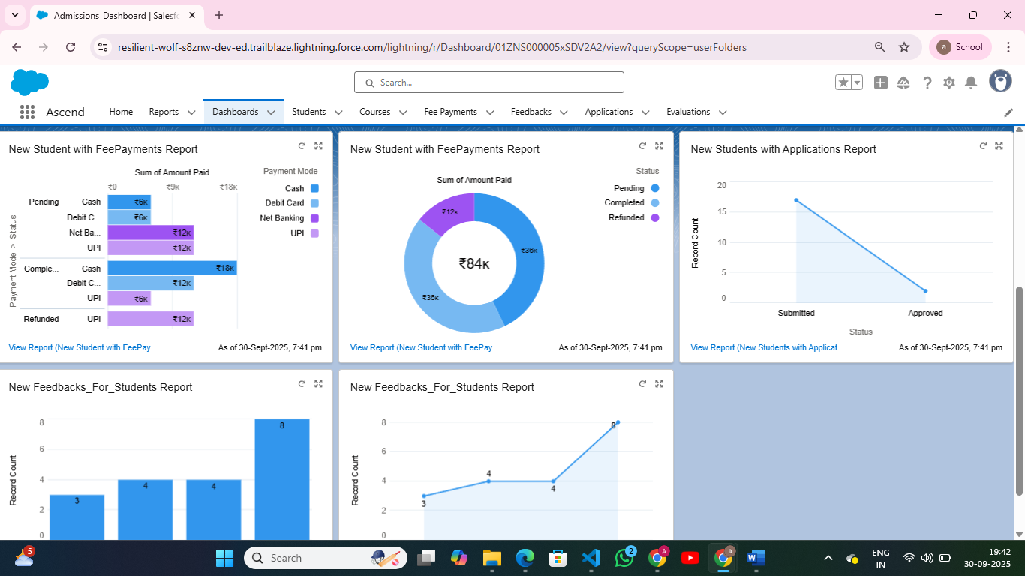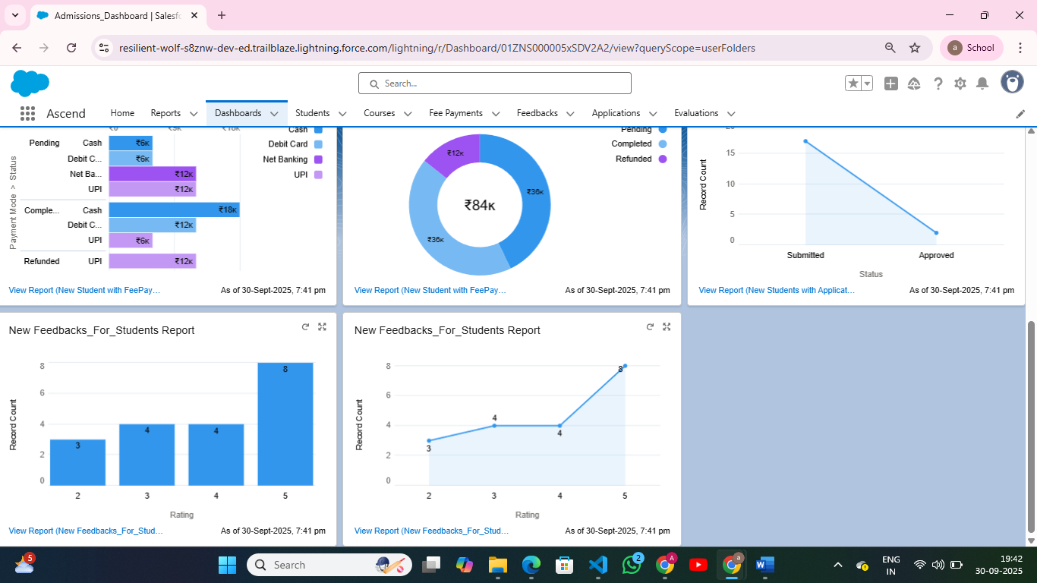

**Sharing Settings**

* Control record visibility across org.
* **Navigation**: Setup → Security → Sharing Settings → Organization-Wide Defaults → Edit → Define Access Levels → Save.

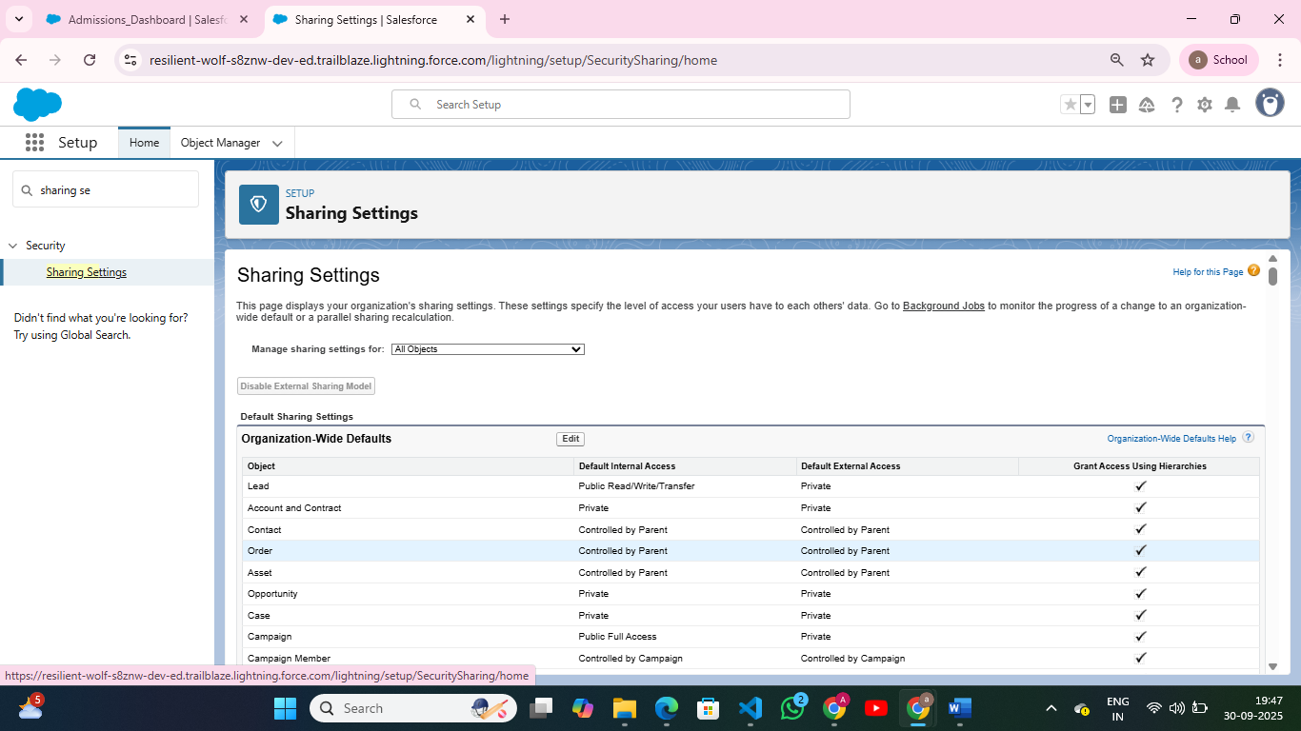

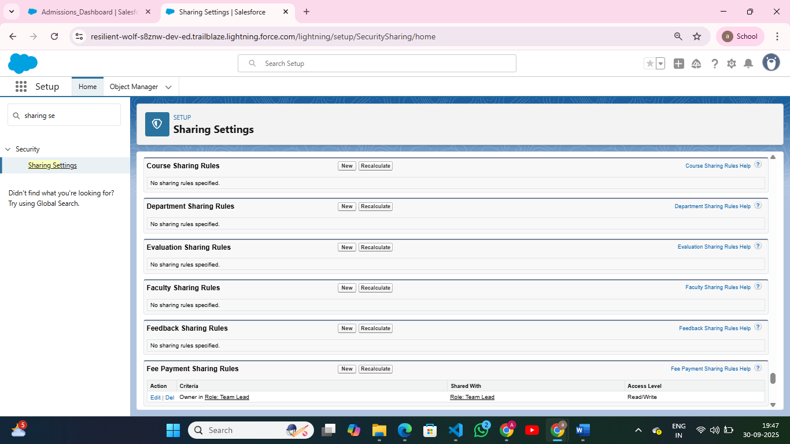

**Field Level Security**

* Restrict visibility or edit access for specific fields.
* **Navigation**: Setup → Object Manager → Student→ Fields & Relationships → Enrollment Status→ Set Field-Level Security → Save.

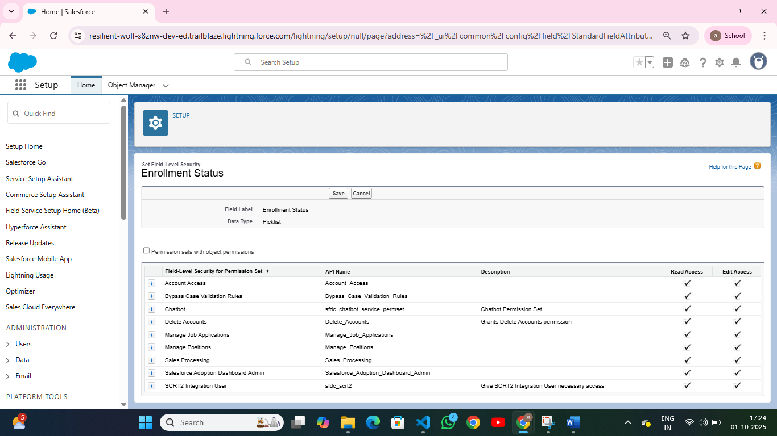

**Session Settings**

* Configure session timeout, login security, and device policies.
* **Navigation**: Setup → Security → Session Settings → Edit → Set Timeout, Force logout → Save.

**Login IP Ranges**

* Restrict user login access to specific IP ranges.
* **Navigation**: Setup → Profiles → [Select Profile] → Login IP Ranges → New → Enter Start/End IP → Save.

**Audit Trail**

* Track changes made to setup configuration.
* **Navigation**: Setup → Security → View Setup Audit Trail → Download/View Changes